Stress-Testing Historical Perspective Taking: Ideological Attitudes and Disciplinary Reasoning
Juda Kaletaª*
ª Institute of History, Faculty of Arts, Charles University, Czech Republic; Doctorado en Educación, Universidad de Murcia, Spain.
*Corresponding author: Juda Kaleta
Filozofická fakulta, Univerzita Karlova
nám. Jana Palacha 1/2
116 38 Praha 1
Czech Republic
juda.kaleta@ff.cuni.cz
Stress-Testing Historical Perspective Taking: Ideological Attitudes and Disciplinary Reasoning in Czech Adolescents
Historical Perspective Taking (HPT) is widely regarded as a core dimension of disciplinary historical reasoning, yet its construct validity remains vulnerable to theoretically plausible threats. One such threat is ideological congruence: students whose contemporary attitudes align with those of historical actors may appear contextually competent without engaging in disciplinary contextualization. This study examines whether authoritarian and pro-Nazi-leaning attitudes constitute a source of construct-irrelevant variance in a widely used HPT instrument (Hartmann & Hasselhorn, 2008).
Data were collected from 293 Czech secondary students nested in 20 classrooms. Multilevel models tested whether right-wing authoritarian attitudes predicted HPT scores, controlling for historical knowledge and social desirability. Differential item functioning and multi-group confirmatory factor analysis assessed measurement invariance across ideology groups.
Ideological attitudes were unrelated to overall HPT performance or to contextualization subscores. Knowledge emerged as the only consistent predictor. Measurement models demonstrated full scalar invariance, and equivalence testing indicated that any ideology effects fell within a region of practical equivalence.
Within the ideological range typical of mainstream classrooms, HPT appears epistemically robust against motivated alignment, clarifying boundary conditions for its validity as a measure of disciplinary contextualization.
Keywords: historical perspective taking; construct validity; ideological contamination; measurement invariance; differential item functioning; multilevel modeling

Introduction
Historical thinking - the capacity to reason about the past using disciplinary methods rather than naive intuition - has become a central goal of history education across multiple national curricula (Seixas & Morton, 2013; van Drie & van Boxtel, 2007; Wineburg, 2001). Among the competences subsumed under historical thinking, historical perspective taking (HPT) occupies a distinctive position. Unlike sourcing or corroboration, which focus on handling evidence, HPT requires students to reconstruct the beliefs, values, and circumstances that made past actors' decisions intelligible to them at the time (Hartmann & Hasselhorn, 2008; Lee & Ashby, 2001). This cognitive achievement - understanding without endorsing - is widely regarded as among the most challenging aspects of historical literacy (Seixas, 2017; Wineburg, 2001).
The construct matters not only for curriculum and pedagogy but also for assessment. If education systems are to take historical thinking seriously as a learning outcome, they need instruments capable of measuring it reliably and validly (Breakstone et al., 2013; Seixas & Ercikan, 2015). Over the past two decades, several instruments have been developed for this purpose, with the scenario-based measure introduced by Hartmann and Hasselhorn (2008). representing one of the most widely cited attempts at standardized HPT assessment. Their instrument presents students with a historically plausible scenario - a young man in the Weimar Republic deliberating whether to join an extremist movement - and elicits responses on a four-point scale across items tapping three theoretically derived levels of HPT: presentism, recognition of the historical agent's role, and contextualisation.
Yet the very feature that makes HPT assessment educationally meaningful - its reliance on content-rich historical scenarios involving morally charged decisions - also introduces a validity concern that has received insufficient attention. When a scenario involves a historical figure contemplating ideologically charged political alternatives, students' responses may be shaped not only by their capacity for disciplinary reasoning but also by their personal ideological commitments. A student with right-authoritarian attitudes might appear to "contextualize" the agent's decision not because they are reasoning historically, but because they sympathize with the ideological content of the scenario. If so, the instrument would be measuring something other than, or in addition to, the construct it claims to assess.
This concern maps directly onto the concept of construct-irrelevant variance (CIV), a central threat to validity within the unified framework articulated by Messick (1995) and codified in the Standards for Educational and Psychological Testing (American Educational Research Association, American Psychological Association, National Council on Measurement in Education, 2014). CIV occurs when systematic variance in test scores is attributable to factors extraneous to the target construct - in this case, when ideological attitudes inflate HPT scores independently of disciplinary reasoning. If CIV from ideology is present, group comparisons and individual inferences drawn from HPT scores would be compromised, potentially rewarding ideological sympathy rather than historical understanding.
It is important to be precise about what kind of threat this represents. Several distinct mechanisms could link ideology to HPT scores: (a) construct contamination in the strict sense, where ideological sympathy inflates scores without any corresponding reasoning competence; (b) construct overlap, where the scenario content genuinely measures something that is both part of HPT and partially ideologically determined; (c) a true causal effect of ideology on the underlying reasoning process, for instance if authoritarian students approach historical inference differently; and (d) differential task engagement, where ideologically aligned students invest more cognitive effort in the scenario. The present study focuses specifically on mechanism (a) - whether ideological attitudes introduce score inflation independent of disciplinary reasoning. Distinguishing (a) from (c) in principle requires process data (e.g., think-aloud protocols) that the current design does not provide; accordingly, we interpret null ideology effects as evidence against score inflation, while remaining agnostic about whether ideology shapes the reasoning process in ways that do not manifest in score differences.
Despite its theoretical salience, this threat has not been empirically tested. The present study addresses this gap through a preregistered investigation of whether right-authoritarian ideological attitudes predict HPT scores in a sample of Czech secondary students, and whether any such relationship persists after accounting for historical knowledge and socially desirable responding. We complement these hypothesis tests with item-level analyses - differential item functioning (DIF) and multi-group confirmatory factor analysis (MG-CFA) - to determine whether the measurement properties of the HPT instrument are invariant across ideological groups. In terms of contribution type, the study constitutes a boundary-condition validation of HPT under ideological heterogeneity: it subjects an existing, widely used HPT measure to a targeted validity challenge within democratic classroom contexts, asking whether historical perspective-taking can be measured with epistemic fairness when students hold diverse ideological commitments.

Competing Theoretical Predictions
It is worth noting that the direction of any ideology-HPT relationship is not theoretically settled. The contamination hypothesis assumes that right-authoritarian students would score higher on the WEimar scenario because they sympathize with the content: a young man weighing the appeal of an extremist movement in a context of perceived national humiliation overlaps affectively with themes central to right-authoritarian ideology (nationalist grievance, strong-leader appeal, anti-democratic sentiment). On this congruence pathway, ideological sympathy reduces the psychological effort required to contextualize the scenario, thereby inflating scores as a side effect of attitude alignment rather than reasoning quality.
However, an entirely different prediction follows from research on authoritarian cognition. High authoritarianism is associated with reduced integrative complexity - the capacity to hold multiple conflicting perspectives simultaneously (Duckitt, 2001; Suedfeld & Tetlock, 1977). Historical perspective taking, which requires situating historical actors within unfamiliar value systems while simultaneously maintaining a present-day analytical stance, is precisely the kind of cognitively integrative task for which reduced complexity should manifest as poorer performance. On this rigidity pathway, authoritarian students would score lower on the HPT, independent of their ideological congruence with the scenario.
These two pathways generate opposite predictions and could partially cancel in aggregate data, producing a null correlation even when both mechanisms are operating. The preregistered hypotheses (H1 and H2) focus on the congruence pathway - the theoretically dominant concern for construct validity. An exploratory secondary analysis examines whether the rigidity pathway is detectable in the data.

Hypotheses
Following the preregistered protocol, we tested two directional hypotheses:
- H1 (Ideological contamination). Students with stronger right-authoritarian attitudes score higher on HPT, consistent with construct-irrelevant variance from ideological sympathy with the scenario content.
- H2 (Persistence after controls). The H1 relationship persists after controlling for prior historical knowledge and social desirability, indicating that the ideological signal is not reducible to confounds.
Complementary measurement analyses tested whether the HPT items function equivalently across ideology groups (DIF) and whether the factor structure is invariant (MG-CFA).

Literature Review

Historical Perspective Taking: Conceptualization
HPT refers to the ability to understand the actions, decisions, and worldviews of people in the past by reconstructing the historical context in which they operated (Hartmann & Hasselhorn, 2008; Lee & Ashby, 2001). The concept has roots in British traditions of history education that distinguished "empathy" - understood not as emotional identification but as rational reconstruction - from naive presentism (Ashby & Lee, 1987). Lee and Ashby (2001) argued that understanding historical actors requires setting aside present-day moral frameworks and recognizing that past decisions were made within fundamentally different belief systems, institutional structures, and material conditions.
Hartmann and Hasselhorn (2008) operationalized this theoretical framework into a developmental model with three hierarchical levels. At the lowest level, presentism (POP) students judge historical actors by contemporary standards without recognizing the alien character of the past. At an intermediate level, recognition of the historical agent's role (ROA) involves acknowledging that the agent occupied a socially recognizable role (e.g., father, soldier), but does not fully reconstruct the contextual forces shaping the agent's reasoning. At the highest level, contextualization (CONT), students situate the agent's decisions within the specific historical conditions - political, economic, cultural - that rendered those decisions intelligible at the time.
Achieving contextualisation requires an epistemically demanding discipline: students must hold historical alterity - the fundamental difference of past thought, institutions, and values - in analytical view while simultaneously maintaining a critical scholarly stance toward the present. This is the epistemic norm Lee and Ashby (2001) called "rational understanding": understanding without endorsing, inhabiting a past perspective without surrendering present-day moral judgment. Measured against this standard, contextualisation is not merely a higher developmental level but a specific epistemic achievement that distinguishes disciplinary historical reasoning from culturally or ideologically assimilated interpretation.
This three-level model draws on earlier developmental work by Lee and Ashby (2001) as well as Selman's (1980) social perspective-taking framework, while insisting that HPT is domain-specific: it requires understanding not merely another person's viewpoint, but a viewpoint embedded in a fundamentally different historical context.
Subsequent work by Huijgen and colleagues (2014, 2017) extended this framework to larger samples and different historical topics, confirming the core theoretical structure while highlighting the difficulty of contextualisation for most students. Van Boxtel and van Drie (2018) situated HPT within a broader framework of historical reasoning that also encompasses the use of evidence, the construction of arguments, and the employment of substantive concepts. Across these frameworks, HPT is understood as a cognitively demanding, knowledge-dependent form of reasoning - not a disposition or attitude, but a competence that requires both domain-specific knowledge and the disciplinary capacity to deploy that knowledge in reconstructing past perspectives (Chapman, 2021).

Measuring HPT: The Scenario-Based Approach
The difficulty of measuring HPT stems from its inherently interpretative character. Unlike factual recall, HPT can be assessed to a limited extent using multiple-choice items with a single correct answer (Smith, 2017; Smith et al., 2018). Hartmann and Hasselhorn (2008) addressed this challenge by designing a scenario-based instrument in which students read a historically plausible narrative and then respond to nine Likert-scaled statements (1-4), each representing one of the three HPT levels (POP, ROA, CONT; three items per level). This approach has several advantages: it is efficient to administer, enables standardized scoring, and produces interval-level data suitable for statistical modeling.
In the original validation study (n = 170 German students, Grade 10), Hartmann and Hasselhorn (2008) found that the three HPT levels could be recovered through principal component analysis, and that students classified at the highest level (contextualisation) had significantly better history grades. The scenario - a young man in the Weimar Republic weighing whether to join an extremist political movement - was designed in consultation with historians to be age-appropriate and thematically connected to the German curriculum.
However, the instrument's psychometric properties also reveal limitations. Internal consistency for three-item subscales is inherently constrained; in the subsequent replication study by Huijgen et al. (2014), Cronbach's alpha values for the individual subscales were modest.

Validity Framework: Construct-Irrelevant Variance
The unified validity framework (American Educational Research Association, American Psychological Association, National Council on Measurement in Education, 2014; Messick, 1995) conceptualizes validity not as a property of a test but as the degree to which evidence and theory support the interpretations of test scores for their intended uses. Two principal threats undermine score interpretations: construct underrepresentation (the test fails to capture important aspects of the construct) and construct-irrelevant variance (CIV; the test captures systematic variance from sources other than the target construct).
CIV is particularly concerning when test content intersects with respondents' attitudes, beliefs, or social identities. Messick (1995) emphasized that validity evidence must address not only whether scores correlate with theoretically expected criteria but also whether they are free from systematic contamination by irrelevant factors. The Standards (American Educational Research Association, American Psychological Association, National Council on Measurement in Education, 2014) elaborate that evidence of internal structure, including measurement invariance across relevant subgroups, constitutes essential validity evidence when scores are used to compare groups or make inferences about individuals.
In the context of HPT measurement, the CIV concern is straightforward. The Hartmann and Hasselhorn (2008) scenario asks students to reason about a historical figure contemplating political extremism. If students with right-authoritarian attitudes systematically score higher - not because they reason more historically but because they feel affinity with the scenario's ideological content - then HPT scores contain construct-irrelevant variance. This would compromise the instrument's use for measuring disciplinary reasoning and would be particularly problematic in educational contexts.
The concern is not merely hypothetical. Alvén (2019) documented ideological bias in teachers' assessments of students' historical narratives, suggesting that ideological content can infiltrate judgments of historical competence. More broadly, research on attitude-consistent responding in educational measurement has shown that test items touching on politically or morally charged content can elicit responses driven by attitudes rather than the intended cognitive processes (Badham et al., 2025). The underlying mechanism is well-documented in political psychology: individuals process information in identity-protective ways, filtering evidence through pre-existing commitments to preserve group identity and ideological coherence (Jost et al., 2003; Kahan et al., 2017). If such processes operate during HPT responses, students whose ideological identity aligns with the historical actors in the scenario may interpret contextualizing cues as confirming their worldview rather than as evidence of historical distance.

The Czech Educational Context
The Czech Republic provides an apt setting for this investigation. As a post-communist society, it has a complex relationship with totalitarian ideologies, and the Weimar Republic scenario resonates with broader European and Czech historical experiences of democratic fragility and radicalization (Činátl et al., 2021) as well as with the latest trends toward far-right extremism.
Czech history education has traditionally followed a transmissive model emphasizing factual knowledge, though recent reforms and initiatives - including the HistoryLab History+ project - have sought to promote historical thinking competences including perspective taking (Havlůjová & Najbert, 2017; Münich et al., 2023; Ripka et al., 2023).
Czech adolescents are exposed to narratives about totalitarianism through the national curriculum, family memory, and public discourse, making the relationship between ideological attitude and historical reasoning both educationally relevant and socially significant. For an international readership, it is worth noting that the Weimar Republic unit holds particular resonance in Czech classrooms because it connects directly to subsequent Czech historical experience: the 1938 Munich Agreement, the cession of the Sudetenland, and the Nazi occupation of 1939-1945.

Method

Participants and Procedure
The sample comprised 293 students from 20 classrooms across 10 schools in the Czech Republic. The sample spanned both the final year of lower secondary (ISCED 2; n=87, 29.7%) and upper secondary (ISCED 3; n=206, 70.3%) school level. Schools were drawn from five Czech regions (Praha: n = 125, 42.7%; Královéhradecký: n = 102, 34.8%; Zlínský: n = 33, 11.3%; Jihomoravský: n = 24, 8.2%; Ústecký: n = 9, 3.1%) and three school-funding categories (public: n = 266, 90.8%; private: n = 19, 6.5%; church-affiliated: n = 8, 2.7%). After excluding cases with missing cluster identifiers (n=6-17 depending on variable combination), the analytic sample ranged from 276 to 287.
The gender composition was 192 males (65.5%), 88 females (30.0%), and 13 students did not submit their gender (4.4%). Students' most recent history course grade averaged 1.71 (SD = 0.92, range 1-5, n = 289) on the Czech grading scale, where 1 = excellent and 5 = failing.
Schools were recruited through convenience sampling. A formal comparison against national school population distributions was not conducted; the sample over-represents male students relative to the national composition and should not be treated as a probability sample of Czech adolescents. Sample size was determined by an a priori power analysis specified in the preregistered protocol, targeting 80% power to detect standardized ideology effects of β ≥ .15 in a two-level multilevel model; the achieved sample met this target.
Within each school, all students present on the day of administration completed the instrument battery during a regular class period. Teachers were present during the administration but did not intervene in students' responses.

Instruments

Historical Perspective Taking (HPT)
We developed a Czech adaptation of the Hartmann and Hasselhorn (2008) scenario-based HPT instrument through forward and backward translation from the original English version by two bilingual Czech-English experts, followed by review of the scenario narrative and all inne items by Czech history educators to ensure conceptual equivalence and age-appropriateness for Czech secondary students. All deviations from the original were logged transparently in the OSF.io repository. The original four-point response format and the three-factor item structure were retained unchanged from the original version. Students read a narrative about a young man in the Weimar Republic who is considering joining an extremist political movement, then responded to nine items on a 4-point Likert scale (1 = strongly disagree to 4 = strongly agree). Three items each tapped presentism (POP1-POP3), recognition of the agent's role (ROA1-ROA3), and contextualisation (CONT1-CONT3).
POP items were reverse-scored (5 - POP) so that higher scores on all items indicate more contextualised, discipline-desirable reasoning. The primary dependent variable was HPT_CTX6, the mean of reversed POP and CONT items (six items), which captures the core contrast between presentism and contextualisation. The nine-item total (HPT_TOT9, adding ROA) served as a secondary outcome in sensitivity analyses. CONT was also analyzed separately as the theoretically highest-level subscale.

Right-Authoritarian Ideology (FR-LF mini)
Ideological attitudes were measured using a six-item short form of the Fragebogen Rechtsextremer Einstellungen — Leipziger Form (FR-LF; Decker et al., 2013) following the same forward and backward translation protocol as HPT with a bilingual Czech-German expert. The scale comprises two facets: acceptance of right-wing dictatorship (RD1-RD3) and National Socialist sympathy/relativization (NS1-NS3), each rated on a 5-point Likert scale (1 = strongly disagree to 5 = strongly agree). Higher scores indicate stronger right-authoritarian attitudes.
The composite FR-LF score (mean of all six items) served as the primary predictor of ideology, representing a generalized right-authoritarian orientation. Facet scores were examined in supplementary models. Theoretically, the NS facet is the most direct operationalization of the content congruence contamination pathway: students endorsing NS items sympathize with the ideological content most proximate to the Weimar scenario, while the RD facet indexes a broader preference for strong-leader authoritarianism. This distinction was tested in the NS-only invariance analysis.

Authoritarianism (KSA-3)
We administered the Kurze Skala Autoritarismus (KSA-3; Beierlein et al., 2014), translated by the same expert as the FR-LF instrument, a nine-item measure of authoritarian attitudes comprising three facets: authoritarian aggression (A1-A3), authoritarian submission (U1-U3), and conventionalism (K1-K3), each rated on a 5-point scale. KSA-3 server as a convergent indicator of the authoritarian attitude domain alongside FR-LF, as preregistered. Theoretically, KSA-3 operationalizes the cognitive rigidity pathway: authoritarian aggression, submission, and conventionalism are, in the literature, associated with reduced integrative complexity (Duckitt, 2001; Suedfeld & Tetlock, 1977), which could inhibit rather than enhance HPT performance. The inclusion of both FR-LF and KSA-3 thus allows the study to test both the congruence pathway (which predicts higher scores for ideology-concordant students) and the rigidity pathway (which predicts lower scores for cognitively authoritarian students) simultaneously.

Historical Knowledge (KN)
Prior historical knowledge was assessed using a six-item multiple-choice test (KN1-KN6) published in Huijgen et al. (2017) covering content directly relevant to the HPT scenario: the political, economic, and social conditions of the Weimar Republic, the rise of extremist movements in interwar Germany, and the circumstances facing young people in 1930s Germany. Each item was scored dichotomously (0 = incorrect, 1 = correct), yielding a sum score ranging from 0 to 6.

Social Desirability (SDR-5)
Social desirability was measured using the five-item short form developed by Hays et al. (1989), with items rated on a 5-point scale. Items SDR-2-SDR4 were reverse-coded prior to data collection per the published scoring protocol. The SDR-5 mean served as a control variable to address the possibility that apparent HPT performance reflects socially desirable responding rather than genuine reasoning.

Analytic Approach
All analyses were conducted in R (version 4.4.2) using lme4 and lmerTest for multilevel models, lavaan for CFA, and mirt for IRT-based DIF analysis.

Measurement Quality
We first evaluated the internal structure and reliability of the HPT instrument. Confirmatory factor analyses (CFA) compared one-factor, two-factor (POP+CONT vs. ROA), and three-factor (POP, ROA, CONT) models using the WLSMV estimator for ordered-categorical data. Reliability was assessed via Cronbach's alpha (raw and polychoric) and McDonald's omega. Inteclass correlations (ICCs) were computed to quantify school- and classroom-level variance in HPT scores, informing the multilevel modeling strategy.

Differential Item Functioning
To test whether individual HPT items function differently across ideology groups, we formed Low and High ideology groups using tertile splits on a composite ideology score (the mean of z-scored FR-LF and z-scored KSA-3 composites). The middle tertile was excluded to maximize contrast between groups. This approach follows established practice in DIF and MG-CFA research, where extreme group designs improve detection sensitivity (Finch, 2005). We acknowledge that tertile splits are sample-dependent and reduce available N (to approximately n=80-96 per group), which limits sensitivity to small DIF effects; these limitations are discussed in the Limitations section. As a supplementary sensitivity check, we also ran MG-CFA using NS-only grouping to verify that the invariance finding is not an artifact of the composite ideology definition.
We fitted a constrained multi-group graded response model (slopes and intercepts constrained to equality, latent means and variances free) and tested each item for DIF using likelihood-ratio tests with a Bonferroni correction (α = .01). Both uniform DIF (threshold differences) and non-uniform DIF (slope differences) were tested.

Multi-Group CFA
Measurement invariance was assessed through a stepwise multi-group CFA across the Low and High ideology groups: configural (same factor structure), metric (equal loadings), and scalar (equal loadings and thresholds). Models were estimated with WLSMV on ordered items. Invariance was evaluated using changes in CFI (ΔCFI ≤ .01) and RMSEA (ΔRMSEA ≤ .015), following established guidelines (Chen, 2007; Cheung & Rensvold, 2002).

Hypothesis Tests
H1 and H2 were tested using random-intercept multilevel models with students nested in classrooms within schools (two random intercepts: school and class). All predictors were z-standardized for comparability. The base model specification was:
$HPTᵢⱼₖ = γ₀₀+γ₁₀ FR_LFᵢⱼₖ+γ₂₀ KSAᵢⱼₖ+γ₃₀ KNᵢⱼₖ+γ₄₀ SDRᵢⱼₖ+u₀ⱼ+u₀ₖ+eᵢⱼₖ$ (1)
where i indexes students, j classrooms, and k schools. This model tests H2 directly (ideology predicting HPT after controlling for other variables). H1 was assessed through zero-order correlations and by inspecting the ideology coefficient in models without a control variable. Supplementary models examined FR-LF facets (RD, NS) separately and the FR-LF × KN interaction. The moderate correlation between FR-LF and KSA-3 (r = .52) was the largest inter-predictor correlation; given the remaining small predictor intercorrelations (|r| ≤ .19; see Table 4), variance inflation factors (VIFs) for all model predictors were below 2.0 in every model specification, indicating that multicollinearity did not constitute a threat to the coefficient estimates.

Sensitivity Analyses
Robustness was assessed across (a) alternative HPT scoring composites (6-item, 8-item, 9-item), (b) different ideology operationalizations (FR-LF total, NS facet, KSA-3 total), © exclusion of high social desirabelity responders (top 10%), (d) random-slope models allowing ideology effects to vary across classrooms, and (e) school fixed-effects models replacing school random intercepts with school dummy variables.
To move beyond preregistered null-hypothesis significance testing and provide formally bounded inference about ideology effects, we conducted two additional analyses. First, formal two one-sided tests (TOST; Lakens, 2017) were used to test equivalence between the observed ideology effects and a region of practical equivalence defined by the SESOI of β = ±0.20 - the threshold below which ideology effects would be too small to influence educational decisions about instrument use (corresponding to approximately 4% explained variance; Cohen, 2009). Second, a Mundlak-style contextual effects model (Mundlak, 1978) decomposed ideology into within-class centered scores and class-mean scores, testing whether classroom-level ideological climate predicts HPT outcomes independently of individual ideology.

Results

Descriptive Statistics
Table 1 and Figure 1 present descriptive statistics for all study variables. HPT scores showed the expected ordering across subscales: students scored highest on reversed presentism (POP_rev: M = 2.97, SD = 0.64), followed by role of agent (ROA: M = 2.80, SD = 0.68) and contextualisation (CONT: M = 2.71, SD = 0.74). The primary composite HPT_CTX6 had a mean of 2.84 (SD = 0.55) on the 1-4 scale.
Ideology scores were below the scale midpoint (FR-LF: M = 2.48, SD = 0.75; KSA: M = 2.86, SD = 0.62), indicating that most students did not endorse strong right-authoritarian attitudes. Both ideology distributions were positively skewed, with the mass of responses concentrated in the lower range of the scales, consistent with floor effects typical of right-extreme attitude measures in mainstream adolescent samples. Only 17.7% of the full sample scored above the FR-LF scale midpoint (3.0). Even within the "High ideology" tertile used in DIF and MG-CFA analyses (n = 96, FR-LF M = 3.20, SD = 0.62), only 50% exceeded the scale midpoint - underscoring that this group represents moderately elevated, not extreme, ideological endorsement. Historical knowledge was moderate (M = 3.04, SD = 1.62 on a 0-6 scale).

Table 1. Descriptive Statistics for Study Variables. Note: HPT items scored on a 1-4 scale; POP items reverse-coded. FR-LF and KSA-3 scored on a 1-5 scale. KN scored as a sum of correct responses (0-6).
Variable | n | M | SD | Min | Max
HPT POP (reversed) | 287 | 2.97 | 0.64 | 1.33 | 4.00
HPT ROA | 287 | 2.80 | 0.67 | 1.00 | 4.00
HPT CONT | 287 | 2.71 | 0.74 | 1.00 | 4.00
HPT CTX6 (primary) | 287 | 2.84 | 0.55 | 1.33 | 4.00
HPT TOT9 | 287 | 2.84 | 0.49 | 1.67 | 3.89
KN Total (0-6) | 293 | 3.04 | 1.62 | 0.00 | 6.00
FR-LF RD | 285 | 2.54 | 0.88 | 1.00 | 5.00
FR-LF NS | 286 | 2.43 | 0.89 | 1.00 | 5.00
FR-LF Total | 284 | 2.48 | 0.75 | 1.00 | 5.00
KSA-3 Total | 283 | 2.86 | 0.62 | 1.00 | 5.00
SDR-5 Total | 283 | 3.02 | 0.63 | 1.00 | 4.60
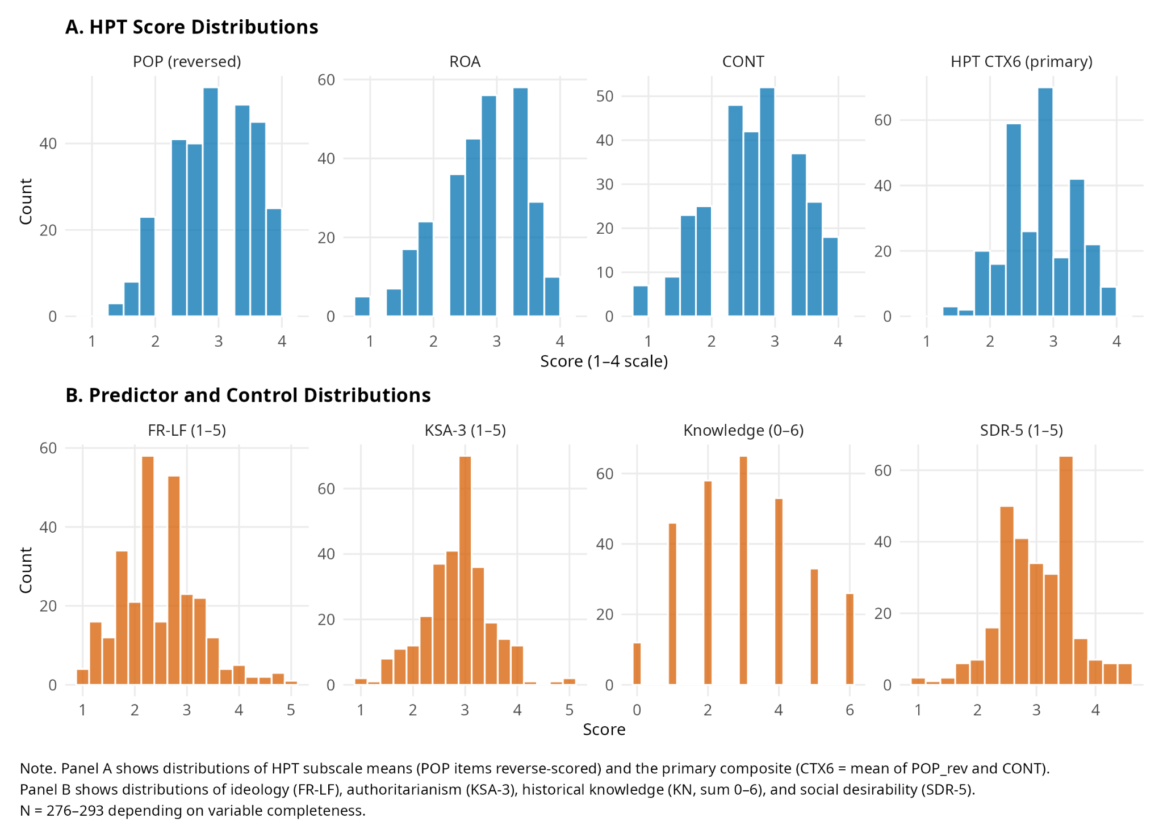

Figure 1. Score distributions for HPT outcomes, ideology predictors, and historical knowledge.yMeasurement Properties of the HPT Instrument

Factor Structure
Confirmatory factor analysis supported the three-factor model (POP, ROA, CONT) as the best-fitting structure for the HPT items in the Czech sample (see Table 2). The three-factor model showed near-perfect fit indices (CFI = 0.999, TLI = .998, RMSEA = .011, 90% CI [.000, .051], SRMR = 0.048; the near-ceiling CFI reflects the three-indicator factor structure rather than genuine model adequacy - see the local fit discussion below), substantially outperforming both the two-factor model combining POP and CONT (CFI = .956, RMSEA = .057) and the one-factor model (CFI = .926, RMSEA = .073).
Standardized factor loadings in the three-factor model ranged from .30 to .74, with CONT items loading most strongly (.61-.72) and POP2 showing the weakest loading (.30). The relatively low loading of POP2 warrants brief comment: a loading of .30 is above the conventional minimum threshold for item retention, and POP2 was retained to preserve fidelity to the original instrument structure. The weak loading suggests that POP2 carries greater unique variance than the other POP items and may tap a slightly distinct facet of presentism; this should be considered in future revisions of the Czech adaptation.
Local fit was evaluated through modification indices and standardized residual correlations. The largest modification index was 7.35 (ROA =~ POP1), below the conventional threshold of 10 that would indicate substantive local misfit. Standardized residual correlations were small, with the largest being POP2-POP3 (r = .13) and ROA3-POP2 (r = -.11). We also tested whether reverse-coding of POP items introduced a method factor by comparing the three-factor model against a version including a method factor for the three reverse-coded items; this did not improve fit meaningfully. The near-perfect global fit indices (CFI = .999) reflect the small item set (9 items in three just-identified three-indicator factors) and should be interpreted alongside the local fit diagnostics, which confirm no substantial misspecification.
These results provide confirmatory evidence for the three-factor structure that the original Hartmann and Hasselhorn (2008) study could only suggest through principal component analysis (N = 170, explained variance 51%). The original study used PCA rather than CFA and noted instability in the separation of POP and CONT as distinct components - a limitation acknowledged in subsequent replications. The present CFA, with a larger Czech sample and a confirmatory framework, establishes that CONT is a separable factor from POP and ROA: the two-factor model forcing POP and CONT onto a single factor showed a meaningfully worse fit (ΔCFI = −.043), confirming that contextualisation represents a distinct facet of HPT rather than simply the absence of presentism.

Table 2. CFA Fit Indices for HPT Factor Models (WLSMV Estimator)
Model | χ² | CFI | TLI | RMSEA | 90% CI | SRMR
1-Factor | - | .926 | .902 | .073 | [.051, .095] | .075
2-Factor (POP+CONT, ROA) | - | .956 | .940 | .057 | [.032, .081] | .066
3-Factor (POP, ROA, CONT) | - | .999 | .998 | .011 | [.000, .051] | .048

Reliability
Internal consistency estimates reflect the inherent constraints of three-item subscales designed to capture heterogeneous facets of a complex cognitive process (Table 3). Raw Cronbach's alpha values were .47 (POP), .50 (ROA), and .64 (CONT). Polychoric alpha, which accounts for the ordinal nature of the items, was somewhat higher: .53 (POP), .53 (ROA), and .69 (CONT). These alpha values are comparable to those reported in the subsequent study by Huijgen et al. (2017).
McDonald's omega total - the appropriate reliability estimate when subscales are embedded within a multidimensional instrument - ranged from .55 to .69. CONT demonstrated the strongest reliability, consistent with its highest average factor loadings.
The modest subscale alphas require contextualisation. Cronbach's alpha penalizes item heterogeneity, and HPT subscales are intentionally broad to represent distinct facets of a multidimensional construct rather than narrow unidimensional traits. A critical test of whether low reliability is producing measurement noise rather than simply reflecting construct breadth comes from the nomological network: if subscales were primarily random noise, no substantive predictor should show consistent associations. Yet historical knowledge predicted HPT outcomes, with standardized coefficients ranging from .21 to .34 across all three subscales. The robustness of this knowledge effect across subscales with varying reliabilities suggests that the instrument carries a genuine signal, and that the modest alpha for POP and ROA reflects construct breadth rather than random error.
Floor and ceiling effects were also evaluated for the HPT composites. The primary composite HPT_CTX6 ranged from 1.33 to 4.00 (Table 1), indicating that the scale ceiling was reachable but that the distribution centered well below it (M = 2.84, SD = 0.55). No student scored at the absolute floor of 1.00 on the composite, and the minimum of 1.33 suggests that the lowest scores reflect genuine responses across items rather than a concentration at the floor. The ideology scales showed no ceiling effects (FR-LF max = 5.00, in range; KSA-3 max = 5.00), and their positive skew reflects the expected floor tendency in mainstream non-extreme samples rather than a measurement artifact.
A further test addresses the concern that low reliability attenuates the observed ideology-HPT correlations, masking a true effect. Correcting the observed zero-order correlation between FR-LF and HPT_CTX6 (r = -.043) for attenuation using the reliability estimates for both measures (α^{FR-LF} = .67; ω_{HPT} ≈ .65) yields a disattenuation-corrected r = -.065. This calculation indicates that attenuation does not plausibly mask a moderate association: even under the optimistic assumption of perfect reliability, the estimated true-score correlation remains trivially small, well below any practical significance threshold.

Table 3. Reliability Coefficients for HPT Subscales. Note: POP items are reverse-scored. α = Cronbach's alpha; ω = McDonald's omega total.
Subscale | Items | α (raw) | α (polychoric) | ω total
POP | 3 | .47 | .53 | .55
ROA | 3 | .50 | .53 | .56
CONT | 3 | .64 | .69 | .69

Intraclass Correlations
ICCs indicated meaningful school-level clustering for most HPT outcomes (HPT_CTX6: ICC_{school} = 0.041; HPT_TOT9: ICC_{school} = .085; ROA: ICC_{school} = .102), warranting multilevel modeling. Classroom-level variance was generally near zero for the primary composite (HPT_CTX6) but non-negligible for CONT (ICC_{class} = .033) and ROA (ICC_{class} = .104). These patterns support the two-level random-intercept specification used in hypothesis testing.
ICCs for the ideology predictors at the classroom level were small but non-negligible: FR-LF ICC_{class} = .061, KSA-3 ICC_{class} = .097. This indicates modest classroom clustering of ideological attitudes - consistent with shared social environments, peer-group influences, or school selection. This clustering raises the theoretical possibility that ideology might operate as a classroom-level characteristic (a climate effect) rather than solely at the individual level. However, the null individual-level effects across all sensitivity specifications, combined with the negligible magnitude of the ideology ICCs, make a substantial classroom-level contamination pathway unlikely. The random-intercept specification absorbs classroom-level variance in the outcome, and the sensitivity analysis using school fixed effects (see Sensitivity Analyses) further confirms that the null result is not an artifact of any particular variance structure.

Zero-Order Correlations
Table 4 presents Pearson correlations among key study variables. The most striking finding at the bivariate level is the near-complete absence of association between ideology and HPT. The correlation between FR-LF total and the primary HPT composite (HPT_CTX6) was r = -.05; between FR-LF and CONT it was r = .01; and between FR-LF and POP_rev it was r = -.09. KSA-3 showed similarly negligible correlations with HPT outcomes (r = -.03 to .07).
By contrast, historical knowledge (KN) was the strongest correlate of HPT performance: r = .34 with HPT_CTX6, r = .22 with CONT, and r = .32 with POP_rev. The ideology measures correlated moderately with each other (FR-LF - KSA-3: r = .52), confirming convergent validity within the authoritarian attitude domain. Social desirability showed weak negative associations with ideology (FR-LF - SDR: r = -.19) and was unrelated to HPT (r = -.02).

Table 4. Zero-Order Pearson Correlations Among Key Variables. Note: Pairwise complete observations (n = 276-287). HPT_POP is reverse-scored.
 | HPT_CTX6 | HPT_CONT | HPT_POP | KN | FR-LF | KSA | SDR
HPT_CTX6 | -
HPT_CONT | .82 | -
HPT_POP (rev) | .76 | .26 | -
KN Total | .34 | .22 | .32 | -
FR-LF Total | -.05 | .01 | -.09 | -.10 | -
KSA-3 Total | -.03 | .07 | -.13 | .05 | .52 | -
SDR-5 Total | -.02 | .01 | -.05 | .03 | -.19 | -.15 | -

Differential Item Functioning
DIF analysis tested whether individual HPT items functioned differently across Low and High ideology groups (defined by a tertile split on the IDEO_{z} composite). Using a constrained multi-group graded response model with likelihood-ratio tests for each item (Bonferroni-adjusted α = .01), no items were flagged for either uniform or non-uniform DIF (Table 5). All adjusted p-values exceeded .01, indicating that the item parameters - both discrimination (slopes) and threshold (location) parameters - were statistically equivalent across ideology groups.

Table 5. DIF Results per HPT Item (Multi-Group Graded Response Model). Note: Non-uniform DIF tests slope (discrimination) differences; uniform DIF tests threshold differences. All p-values Bonferroni-adjusted (α = .01). 0 of 9 items flagged.
Item | p (non-uniform) | p (uniform) | Flagged
POP1 | > .01 | > .01 | No
POP2 | > .01 | > .01 | No
POP3 | > .01 | > .01 | No
ROA1 | > .01 | > .01 | No
ROA2 | > .01 | > .01 | No
ROA3 | > .01 | > .01 | No
CONT1 | > .01 | > .01 | No
CONT2 | > .01 | > .01 | No
CONT3 | > .01 | > .01 | No

Multi-Group CFA: Measurement Invariance
The stepwise MG-CFA across Low and High ideology groups demonstrated full measurement invariance (Table 6). The configural model, which allowed all parameters to differ across groups, showed adequate fit (CFI = .978, RMSEA = .055, SRMR = .079). Constraining factor loadings to equality (metric model) produced virtually no change in fit (ΔCFI = .000, ΔRMSEA = −.006), supporting equivalent loadings across groups. Constraining both loadings and thresholds (scalar model) similarly maintained or improved fit (ΔCFI = +.002, ΔRMSEA = −.007), providing evidence for full scalar invariance.

Table 6. Multi-Group CFA Fit Indices Across Invariance Levels (WLSMV). Note: ΔCFI and ΔRMSEA computed relative to the preceding model. Guidelines for invariance: |ΔCFI| ≤ .01, |ΔRMSEA| ≤ .015 (Chen, 2007)
Model | CFI | RMSEA | SRMR | ΔCFI | ΔRMSEA
Configural | .978 | .055 | .079 | - | -
Metric | .978 | .049 | - | .000 | -.006
Scalar | .980 | .042 | - | +.002 | -.007

Full scalar invariance indicates that the factor structure, loadings, and item thresholds of the HPT instrument are equivalent across ideology groups, meaning that observed group differences (or, in this case, the absence thereof) in HPT scores can be attributed to true differences in the latent construct rather than to measurement artifacts. In epistemic terms, this equivalence confirms that all students - regardless of ideological background - face epistemically equivalent demands when responding to the HPT instrument: the items make the same cognitive appeal and require the same interpretive work across ideological groups. This is a necessary condition for measurement fairness in the disciplinary sense: if different students found the items to evoke different cognitive tasks or if the response categories carried different meanings across groups, the instrument could not support equitable assessment of disciplinary reasoning.
As a supplementary sensitivity check to address concerns about the composite ideology grouping, we reran the MG-CFA using groups defined solely by the NS score. Results were consistent with the primary analysis: configural fit indices reached ceiling values (CFI = 1.000, RMSEA = .000), which indicates near-model-saturation rather than a good fit - a known artifact when group sizes are small (n = 80 per group), and the configural model has very few degrees of freedom with ordinal WLSMV estimation. In this configuration, absolute fit statistics are uniformative; invariance is evaluated from ΔCFI relative to the configural baseline. Scalar invariance was supported (metric ΔCFI = −.002, scalar ΔCFI = +.002), both within the |ΔCFI| ≤ .01 criterion. This confirms that measurement invariance holds even when groups are defined by the ideology facet theoretically most likely to interact with the scenario content.
Figure 2 visualizes the primary invariance results through factor loadings (Panel A) and IRT item parameter comparisons (Panel B).

Figure 2. Measurement invariance and DIF across ideological groups. Panel A shows standardized factor loadings from configural MG-CFA. Panel B shows IRT item parameter scatter plots from the multi-group graded response model.
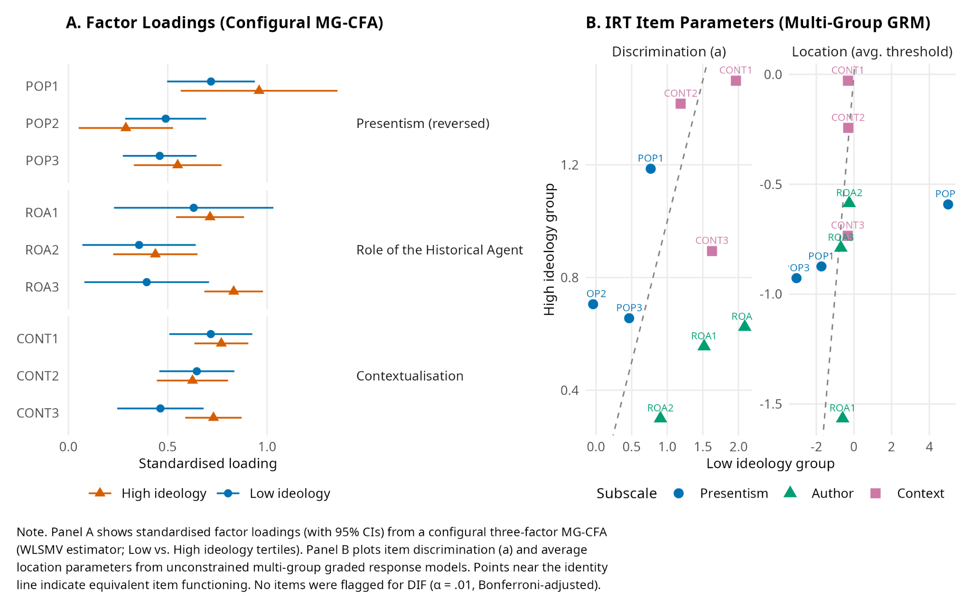

Hypothesis Tests: Multilevel Models

H1: Ideology Predicting HPT (Uncontrolled)
At the bivariate level, the correlations reported in Table 4 already indicate that H1 is not supported: ideology is essentially unrelated to HPT scores. To provide a more rigorous test accounting for the clustered data structure, we also note that zero-order correlations between FR-LF and all HPT outcomes were negligible and non-significant (r = -.09 to .01).

H2: Controlled Multilevel Models
Table 7 presents results from the preregistered multilevel models including all predictors simultaneously. Across all three HPT outcomes and all model specifications (base, facet, interaction), ideology was consistently non-significant.
For the primary outcome HPT total (CTX6), FR-LF was unrelated to HPT scores: β = 0.012, SE = 0.067, 95% CI [−0.120, 0.143], p = .863. KSA-3 was similarly non-significant (β = −0.052, p = .435). Historical knowledge was the only significant predictor (β = 0.336, SE = 0.057, 95% CI [0.223, 0.448], p < .001), accounting for virtually all of the model's explanatory power (R²_{marginal} = .113). Social desirability was non-significant (β = −0.043, p = .455).
For contextualisation (CONT), the pattern was identical: FR-LF β = 0.004, SE = 0.069, 95% CI [−0.131, 0.140], p = .949. Knowledge again emerged as the sole significant predictor (β = 0.211, p < .001). The marginal R² was lower (.049), reflecting the more modest proportion of CONT variance explained by the predictors. The conditional R² (.072) indicated a small additional contribution from classroom-level clustering.
For reversed presentism (POP_rev), FR-LF was again non-significant (β = 0.005, p = .945). Knowledge was a strong predictor (β = 0.334, p < .001). Notably, KSA-3 showed a small but statistically significant negative association with POP_rev (β = −0.159, SE = 0.065, 95% CI [−0.288, −0.031], p = .016), suggesting that students with higher authoritarianism scores were slightly more presentist — the opposite direction from the contamination hypothesis.
This effect was not preregistered and warrants cautious interpretation. Importantly, however, it is directionally opposite to what construct contamination would produce: if ideology were inflating scores, high-KSA students should score higher on POP_rev, not lower. The negative coefficient is instead consistent with a cognitive rigidity account — the well-documented association between high authoritarianism and reduced integrative complexity (Duckitt, 2001; Jost et al., 2003) - whereby authoritarian students find the "unnatural act" of setting aside present-day frameworks more cognitively demanding. On this reading, the KSA-3 result actually supports the instrument's discriminant validity: ideology does not inflate HPT performance, but certain authoritarian cognitive styles may be associated with genuine difficulty at the demanding end of the presentism-contextualisation spectrum.

Table 7. Fixed Effects from Multilevel Models Predicting HPT Outcomes (Standardized Coefficients). Note: Standard errors in parentheses. All predictors z-standardized. Random intercepts for school and classroom. * p < 0.5. *** p < .001.
Predictor | HPT_CTX6 (Base) | CONT (Base) | POP_rev (Base)
FR-LF (z) | 0.012 (0.067) | 0.004 (0.069) | 0.005 (0.066)
KSA-3 (z) | -0.052 (0.066) | 0.062 (0.068) | -0.159* (0.065)
KN (z) | 0.336*** (0.057) | 0.211*** (0.059) | 0.334*** (0.056)
SDR-5 (z) | -0.043 (0.057) | 0.007 (0.059) | -0.082 (0.057)
R²_{marginal} | .113 | .049 | .132
N | 285 | 285 | 285

Figure 3. Forest plot of standardized coefficients (β) with 95% CIs from multilevel models predicting HPT CTX6, Contextualisation, and Presentism (reversed).
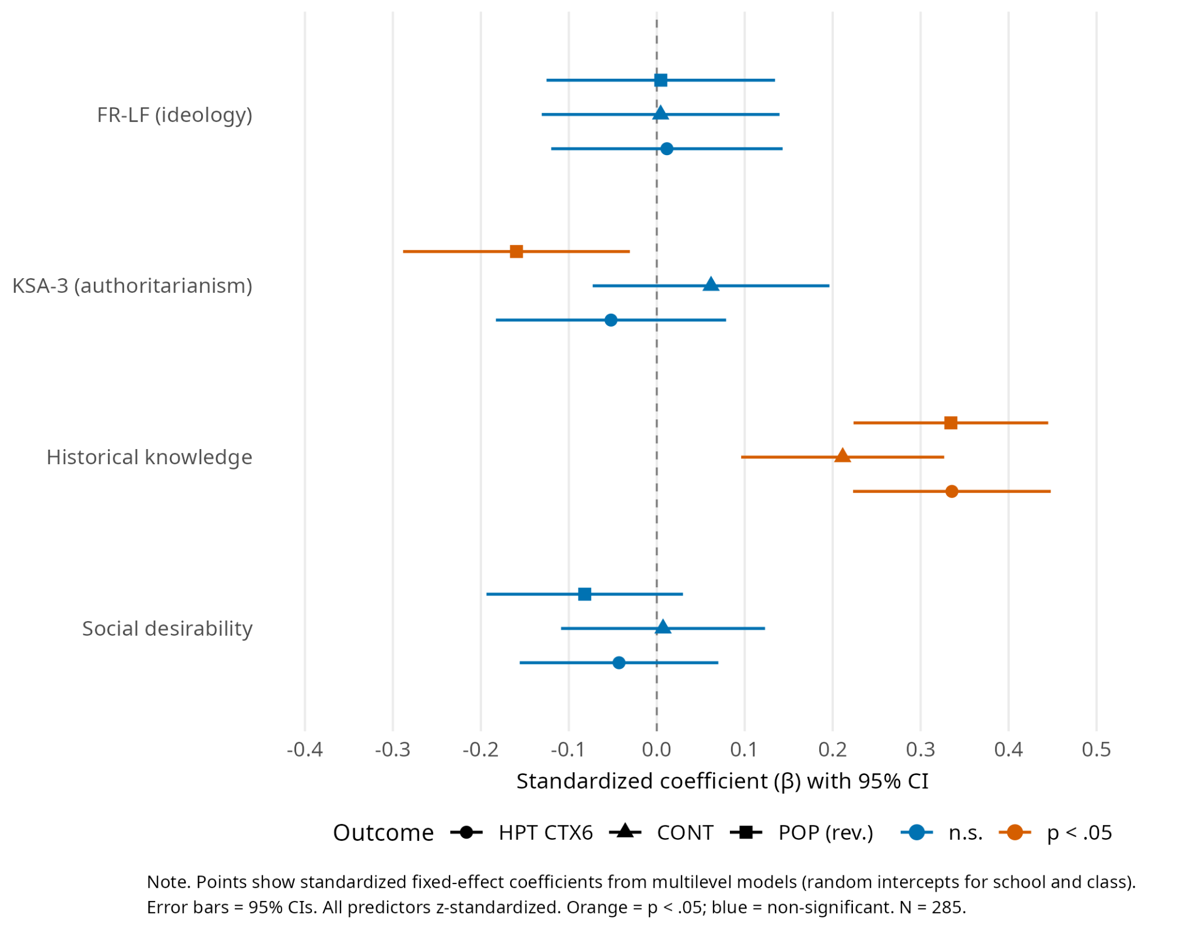

To move beyond conventional null-hypothesis testing, we conducted formal two one-sided equivalence tests (TOST; Lakens, 2017) using a pre-specified SESOI of β = ±0.20 - the threshold below which ideology effects would be too small to influence practical decisions about instrument use (approximately 4% explained variance; Cohen, 2009).
TOST confirmed equivalence for all three HPT outcomes. For HPT_CTX6: TOST p = .0026, 95% CI [−0.120, 0.143]; for CONT: TOST p = .0024, 95% CI [−0.131, 0.140]; for POP_rev**: TOST _p_ = .0017, 95% CI [−0.125, 0.134]. In all cases, the 90% CIs (appropriate for TOST interpretation) fall entirely within the [−0.20, +0.20] equivalence bounds, indicating that ideology effects are statistically ruled out as practically significant at conventional α = .05. The observed point estimates (β = 0.001–0.015 across outcomes) are 13–200 times smaller than the SESOI.
The facet models, which decomposed FR-LF into its RD and NS components yielded the same pattern: neither facet significantly predicted any HPT outcome (all p > .21). The interaction models, testing whether the FR-LF effect was moderated by historical knowledge (FR-LF × KN), found no significant interaction for HPT_CTX6 (β = −0.020, p = .732) or POP_rev (β = 0.074, p = .210). For CONT, the interaction approached but did not reach conventional significance (β = −0.100, p = .099).
Figure 4 visualizes the substantive triviality of the ideology-HPT relationship through predicted marginal effects from the uncontrolled (H1) and controlled (H2) models. Both prediction lines are essentially flat across the full range of observed FR-LF scores, with nearly complete overlap between models.

Figure 4. Predicted marginal effects of ideology on HPT contextualisation from the uncontrolled (H1) and controlled (H2) multilevel models.
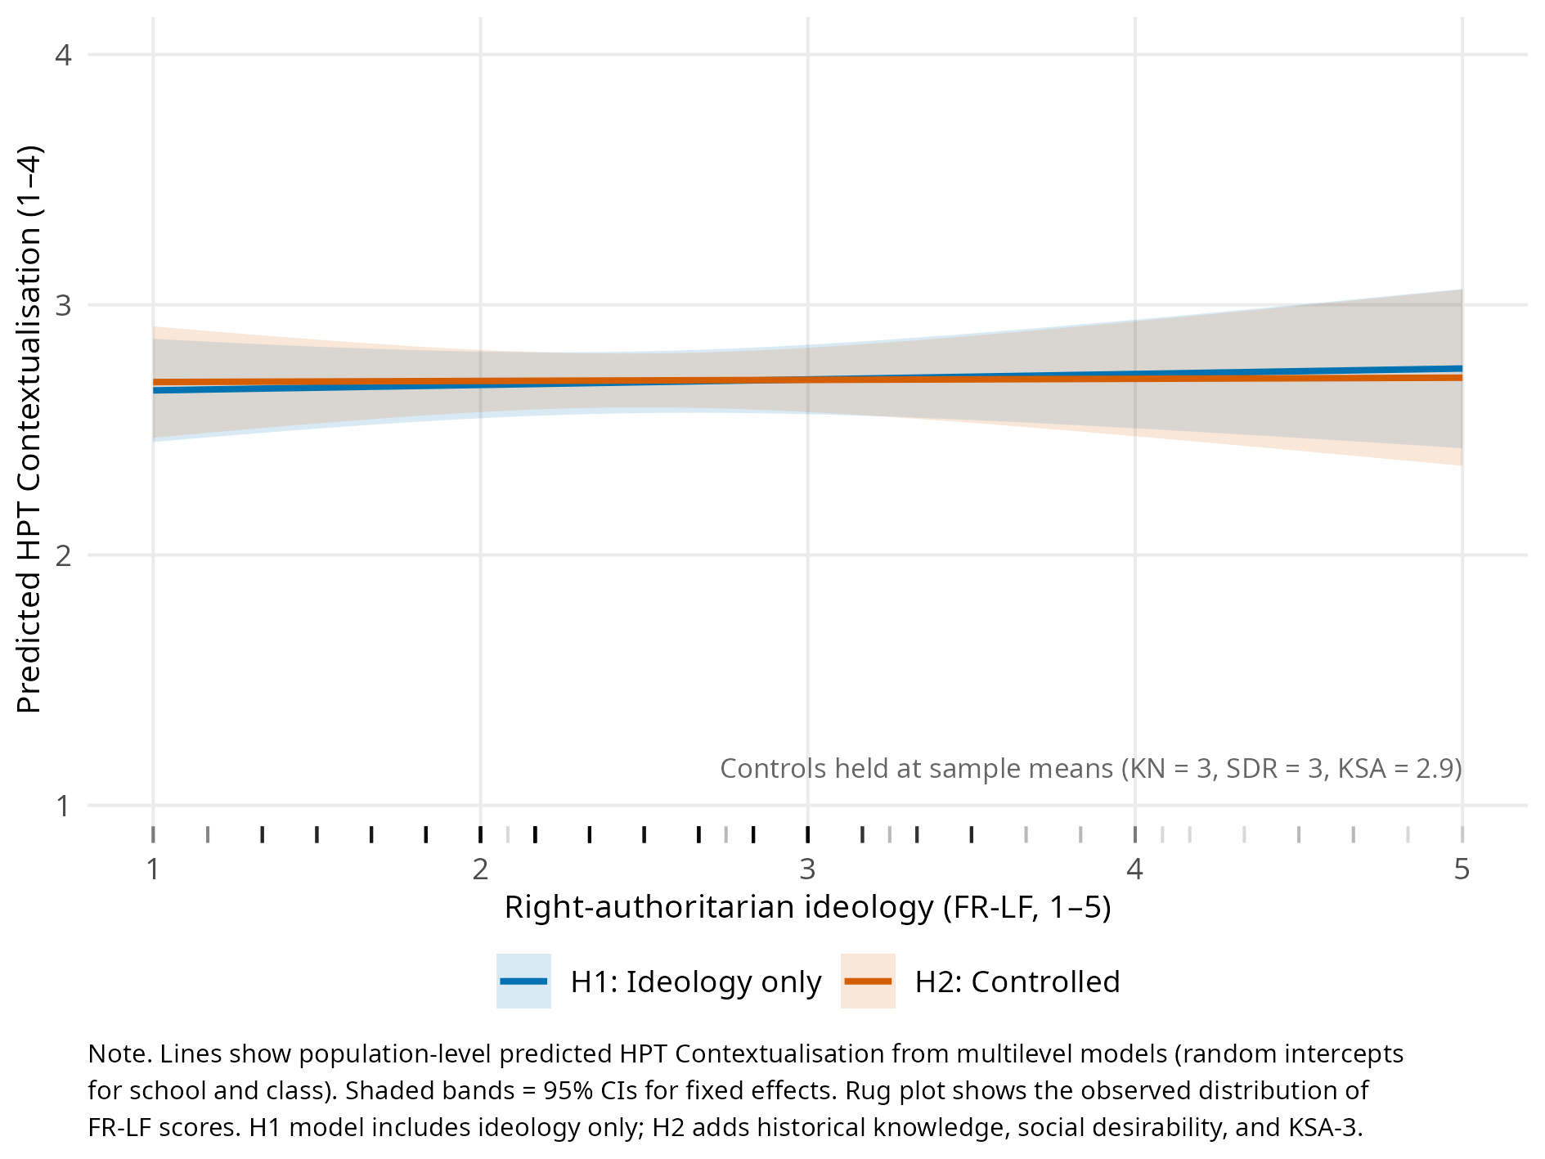

Sensitivity Analyses
The null finding for ideology was robust across all preregistered sensitivity checks (Table 8). Across six alternative model specifications - varying HPT scoring (6-item, 8-item, 9-item), ideology operationalization (FR-LF total, NS facet, KSA-3 total), sample composition (full sample vs. excluding top-10% SDR), and variance structure (random intercepts vs. random slopes for ideology) - the ideology coefficient remained non-significant in every case (all p > .43). Point eistemates clustered tightly around zero, with 95% confidence intervals consistently spanning the null.

Table 8. Sensitivity Analysis: Ideology Coefficients Across Model Specifications. Note: RI = random intercepts; RS = random slopes for ideology; FE = school fixed effects (dummy variables) instead of random intercepts. Excl. = excluding top-10% SDR respondents. All models control for KN and SDR.
HPT Score | Predictor | Sample | Model | B | 95% CI | p
6-item | FR-LF (z) | Full | RI | 0.009 | [-0.057, 0.074] | .798
6-item | FR-LF (z) | Full | RS | 0.007 | [-0.081, 0.096] | .864
6-item | NS (z) | Full | RI | 0.026 | [-0.038, 0.089] | .429
6-item | KSA-3 (z) | Full | RI | -0.020 | [-0.088, 0.048] | .561
8-item | FR-LF (z) | Full | RI | 0.009 | [-0.049, 0.067] | .760
9-item | FR-LF (z) | Full | RI | 0.021 | [-0.037, 0.079] | .471
6-item | FR-LF (z) | Excl. | RI | -0.006 | [-0.075, 0.062] | .853
8-item | FR-LF (z) | Excl. | RI | -0.006 | [-0.068, 0.055] | .838
9-item | FR-LF (z) | Excl. | RI | 0.005 | [-0.056, 0.065] | .876
6-item | FR-LF (z) | Full | FE | 0.028 | [-0.106, 0.163] | .677

Particularly noteworthy is that the null result survived the random-slopes specification, which allows ideology effects to vary across classrooms. This indicates that the absence of an ideology effect is not an artifact of averaging over heterogeneous classroom-level relationships.
To test the classroom climate contamination pathway, we estimated a Mundlak contextual effects model, decomposing FR-LF into within-class centered scores (individual deviation from class mean) and class-mean scores (between-class ideology climate). Neither component predicted HPT in any outcome: within-class FR-LF (HPT_CTX6: β = +0.015, p = .828; CONT: β = +0.001, p = .988; POP_rev: β = +0.023, p = .734) and between-class class mean FR-LF (HPT_CTX6: β = −0.023, p = .909; CONT: β = +0.065, _p_ = .771; POP_rev: β = −0.170, p = .329) were uniformly non-significant. This rules out the possibility that ideology contamination operates at the classroom climate level, even while individual-level effects are zero.
Addressing the concern that multilevel models with only 10 schools may produce biased standard errors (Maas & Hox, 2005), we also estimated the model with school fixed effects (dummy-coded) rather than random intercepts. This specification does not rely on Level-2 sample size assumptions for unbiased inference. The fixed-effects school model yielded FR-LF β = 0.028, SE = 0.068, 95% CI [−0.106, 0.163], p = .677 - virtually identical to the random-intercepts result - confirming that the null ideology effect is not an artifact of the multilevel specification with few schools.

Discussion

Summary of Findings
This study tested whether the Hartmann and Hasselhorn (2008) HPT instrument exhibits ideological contamination within the range of right-authoritarian attitudes typical of Czech secondary classrooms. In all analyses reported here, no detectable contamination was found. Neither of the preregistered hypotheses was supported. Right-authoritarian ideology, measured by both the FR-LF mini and the KSA-3, was unrelated to HPT scores at the bivariate level (r = -.05 to .01) and in multilevel models controlling for historical knowledge and social desirability (all β ≈ 0, all p > .43). The finding was invariant across three HPT scoring composites (6, 8, and 9 items), multiple ideology operationalizations, inclusion and exclusion of high social desirability responders, and models allowing random slopes.
At the item level, DIF analysis found no items that functioned differently across ideology groups at detectable magnitudes under the present sample size, and multi-group CFA demonstrated full scalar invariance - meaning that the factor structure, loadings, and thresholds of the HPT instrument are equivalent for students with low and high ideological attitudes. These converging lines of evidence - from bivariate correlations through latent-variable invariance tests - provide consistent support for the conclusion that HPT scores, under the conditions studied, reflect disciplinary reasoning rather than ideological sympathy with the scenario content. This conclusion is bounded by the ideological range observed in a Czech mainstream school sample, the use of explicit self-report ideology measures, and the specific Weimar Republic scenario; generalization beyond these conditions requires further empirical work.

What Does Predict HPT? The Role of Knowledge
Although the study was designed primarily to test for ideological contamination, a secondary finding is equally consequential: historical knowledge was the only consistent predictor of HPT performance across all outcome specifications. The standardized effect of KN was moderate and robust (β = 0.21 for CONT; β = 0.33–0.34 for HPT_CTX6 and POP_rev; all p < .001), persisting unchanged whether or not ideology was included in the model.
This finding supports the theoretical conceptualization of HPT as a knowledge-dependent competence rather than a general cognitive disposition and is congruent with previous instrument studies. Hartmann and Hasselhorn (2008) emphasized that the ability to take a historical perspective requires domain-specific knowledge about the historical context in question. Our results corroborate this claim empirically: students who knew more about the relevant historical period scored higher on HPT, whereas students' ideological attitudes had no bearing on their performance. Controlling for historical knowledge is theoretically essential here - not merely a statistical precaution - precisely because HPT is constitutively knowledge-dependent: the ability to contextualize past decisions requires knowing the actual political, economic, and social facts that constrained action. By isolating ideology's role after accounting for genuine disciplinary competence, the null ideology effect shows that right-wing authoritarian attitudes do not confer performance benefits beyond what historical knowledge itself predicts. Ideology does not appear to function as a shortcut that delivers context-rich responses without the underlying knowledge - a finding with direct implications for the instrument's validity in heterogeneous classrooms. This is consistent with broader arguments in history education research that disciplinary reasoning depends on substantive historical knowledge (Chapman, 2021; Van Boxtel & Van Drie, 2018; Wineburg, 2001).
The knowledge-HPT relationship also supports the instrument's construct validity through nomological network evidence (Messick, 1995). The pattern of correlations - strong knowledge effects, null ideology effects, null social desirability effects - is precisely what would be expected if the instrument were measuring disciplinary reasoning and not some combination of attitudes and impression management.

Alternative Explanations for the Null Ideology Effect
A finding of no association between ideology and HPT scores is theoretically informative, but several alternative mechanisms could account for the null result independently of the instrument's validity. We consider five such explanations.

Floor effect hypothesis
The most parsimonious alternative is that Czech adolescents did not endorse right-wing authoritarian items strongly enough to generate meaningful ideological variance. With FR-LF below the scale midpoint (M = 2.48, SD = 0.75) and scores concentrated in the lower range, there may not have been enough "true believers" in the sample to test whether extreme ideology inflates HPT scores. On this account, we have not so much tested ideological contamination as demonstrated its absence in a low-ideology general population. We address this interpretation partly by design - the tertile-split analyses deliberately maximized the contrast between groups - and partly by noting that the sensitivity analyses found no ideology effect even within the most ideologically polarized subgroup comparison available in the data. Nevertheless, this interpretation underscores that our results should be read as boundary conditions for mainstream democratic classrooms, not as evidence that the instrument would be uncontaminated under conditions of genuine political extremism.

Moral inhibition override hypothesis
A second possibility is that even students with authoritarian-leaning attitudes suppress ideological responses when completing what appears to be a school assessment. Social desirability could mask ideological sympathy: students may recognize that endorsing extremist historical reasoning is socially unacceptable and respond in line with perceived norms rather than personal attitudes. This interpretation is partially contradicted by the data: social desirability was unrelated to HPT scores (r = -.05 to .01), and the null ideology effect persisted after excluding high-social-desirability responders. The weak negative correlation between SDR-5 and FR-LF (r = -.19) also suggests some tendency toward ideologically inhibited responding, but the effect is small and does not account for the ideology-HPT relationship.

Task constraint hypothesis
The HPT scenario may structure the response options in ways that constrain ideological expression regardless of students' attitudes. When a scenario systematically presents contextual information - historical conditions, social pressures, economic circumstances - students may find it difficult to respond in purely presentist terms even if they wished to, because the scenario itself supplies the contextual scaffolding for higher-level responses. On this reading, the instrument is "contamination-resistant by design" rather than merely free of contamination by accident. This possibility is consistent with the theoretical rationale for scenario-based HPT assessment and is not incompatible with the validity claim, but it highlights that scenario features (not just student reasoning) may partly determine scores.

Cognitive load hypothesis
HPT performance may depend primarily on the inferential effort required to integrate multiple contextual cues, rather than on ideological sympathy or inhibition. If the cognitive demands of contextualizing a historical scenario occupy working memory resources sufficiently to prevent ideology-congruent responding, the null finding would reflect a cognitive mechanism rather than a measurement one. This account aligns with the predominance of knowledge effects: domain knowledge reduces cognitive load in processing the scenario, allowing students to engage more deeply with the contextual cues. Ideological attitudes, which are orthogonal to this processing capacity, would then have a negligible impact on scores.

Dual-process separation hypothesis
Finally, ideological attitudes and contextualized historical reasoning may draw on partially independent cognitive systems. On this view, endorsement of right-authoritarian positions (as captured by explicit self-report) operates primarily at the level of declarative political attitudes, whereas HPT performance recruits situation-model construction and perspective-coordination processes that are more closely allied with narrative comprehension than with attitudinal expression. If so, the two systems need not interact even when their content is congruent, because the task activates historical reasoning pathways rather than attitude-retrieval pathways. This explanation is consistent with the broader literature on dual-process models of social cognition (Evans & Stanovich, 2013) and would predict null associations specifically in structured assessment tasks that channel students into deliberative processing.
None of these alternatives can be definitively ruled out with the present data. Their co-existence does not undermine the practical conclusion - that the instrument shows no measurable ideological contamination in this sample - but it does caution against strong mechanistic interpretations of the null result.

Exploratory Finding: Authoritarianism and Presentism
One finding in the data falls outside the preregistered analyses yet is theoretically informative. KSA-3 (authoritarianism) was significantly and negatively associated with reversed presentism (POP_rev: β = -0.159, SE = 0.065, 95% CI [-0.288, -0.031], p = .016), indicating that more authoritarian students scored slightly lower on POP_rev - that is, they were somewhat more presentist. This effect was not statistically significant for CONT or the primary HPT_CTX6 composite.
This finding runs counter to what construct contamination would predict. Instead, it is consistent with the competing rigidity pathway articulated in the Introduction: students with higher authoritarian attitudes - characterized in the literature by reduced integrative complexity, need for cognitive closure, and resistance to ambiguity (Duckitt, 2001; Suedfeld & Tetlock, 1977) - may find it genuinely more difficult to set aside present-day moral frameworks when reasoning about historical actors. The "unnatural act" of historical perspective-taking may be particularly demanding for authoritarian cognitive styles.
This interpretation has two important implications. First, it reinforces the instrument's discriminant validity: ideology does not inflate HPT performance through sympathy, but certain authoritarian cognitive characteristics may be associated with genuine difficulty on the perspective-taking task. Second, it suggests that a truly comprehensive model of ideology-HPT relationships should test both pathways simultaneously, as they may produce opposing effects that cancel in aggregate analyses. The present data provide initial evidence consistent with the rigidity pathway, but a confirmatory test would require preregistered directional predictions and ideally a direct measure of cognitive closure or integrative complexity. Importantly, this exploratory finding does not alter the primary confirmatory conclusions of the study: it concerns a different mechanism (rigidity, not congruence) and a different direction of effect (lower, not higher HPT scores) than the preregistered contamination hypothesis.

Implications for Assessment
These findings have several implications for the design and interpretation of historical thinking assessments.
First, the results provide positive validity evidence for the HPT instrument developed by Hartmann and Hasselhorn (2008). Despite the morally charged content of the Weimar Republic scenario, students' ideological attitudes did not systematically inflate their scores. This means that the instrument can be used with reasonable confidence across ideologically diverse student populations without the concern that observed differences in HPT scores reflect ideological contamination rather than genuine differences in historical reasoning.
Second, the robustness of full scalar invariance is noteworthy. The invariance of item thresholds across ideology groups means that not only do the items load equivalently, but the response categories carry the same meaning for students with different ideological attitudes. This is the strongest form of measurement invariance and is a necessary condition for meaningful mean comparisons across groups (American Educational Research Association, American Psychological Association, National Council on Measurement in Education, 2014). Assessment developers working on historical thinking instruments can use the present study as a model for empirically evaluating whether scenario content introduces CIV.
Third, the predominance of knowledge as a predictor underscores an often-overlooked feature of performance-based historical reasoning assessments: they are, by design, confounded with domain knowledge (Seixas et al., 2015). This is not a flaw - HPT genuinely requires knowledge - but it means that HPT scores should be interpreted with reference to students' knowledge base. Assessment contexts that wish to isolate "pure" reasoning from knowledge will face fundamental challenges with scenario-based instruments, a point previously raised by Smith (2017) and Breakstone et al. (2014).

Implications for History Education
Beyond psychometrics, the findings contribute to ongoing debates about the relationship between historical thinking and ideological attitudes. A common concern in history education - sometimes explicit, sometimes implicit - is that teaching students to understand past actors' perspectives might inadvertently legitimize morally objectionable positions. The present study offers indirect reassurance: students' capacity to contextualize historical decisions operates independently of their own ideological commitments. Students with right-authoritarian attitudes were neither better nor worse at historical perspective-taking than their peers, suggesting that the cognitive process of historical contextualization is genuinely distinct from ideological sympathy.
This finding resonates with Lee and Ashby's (2001) foundational distinction between understanding and endorsement: HPT involves rationally reconstructing why an agent's actions made sense in context, rather than merely agreeing with those actions. Our results suggest that adolescents in our sample, on average, maintain this distinction in practice - their personal attitudes do not bleed into their reasoning about historical actors.

Limitations
Several limitations warrant discussion. First, the study is based on a single country (the Czech Republic) and a single HPT scenario (the Weimar Republic). The generalizability of the null finding to other national contexts, historical topics, and student populations remains an open question. The Weimar scenario has specific content features - including reference to political radicalization in a European context - that may interact differently with ideological attitudes in countries with different historical experiences or political cultures.
Second, the ideological range represented in the sample is limited. FR-LF scores were concentrated below the scale midpoint, with distributions skewed to the right, reflecting the rarity of strong right-authoritarian endorsement in mainstream Czech classrooms. This constitutes a form of restriction of range that will attenuate observed correlations and reduce the generalizability of the null finding to contexts with genuinely extreme ideological polarization. The present study is best understood as testing ideological contamination under the conditions typical of a democratic public school system - that is, a stress-test of the ordinary classroom, not of a classroom populated by ideologically committed students. Whether the null finding holds in samples with substantially higher ideology variance, in schools embedded in contexts of political radicalization, or with students recruited on the basis of ideological commitment, remains an open empirical question that the present design cannot answer.
Third, the reliability of the HPT subscales is modest (α = .47–.64). While this is expected for three-item subscales and is comparable to values reported in previous studies, low reliability attenuates observed correlations and may have reduced our ability to detect small effects. However, the pattern of results - with knowledge showing robust effects despite the same reliability constraint - argues against attenuation as an explanation for the null ideology finding. If attenuation were the primary issue, knowledge effects would be similarly suppressed.
Fourth, the sample size (N = 285-293 across 10 schools) provides adequate statistical power for detecting moderate effects in multilevel models, but limits sensitivity to small effects. Based on the model structure and observed variances, the minimum detectable standardized ideology coefficient at 80% power is approximately β ≈ 0.12–0.14. The ideology coefficients across all model specifications ranged from -0.006 to 0.026, indicating point estimates well within the undetectable range for very small effects. While the 95% confidence intervals consistently exclude moderate effects (ruling out |β| > ~0.14), small effects of |β| < 0.08 cannot be excluded with confidence. Researchers should note that even a true effect of this magnitude would be substantively negligible for most practical purposes, but this caveat should be borne in mind when interpreting the null results.
For the DIF analyses specifically, splitting N ≈ 250 usable observations into Low and High tertile groups yields roughly n ≈ 80 per group - a modest sample for multi-group IRT with 9 items scored on a 1-4 scale. Non-significant DIF therefore reflects both the absence of flagged items and the limited sensitivity to detect weak, item-level differential functioning. The null DIF result is consistent with invariance but should not be equated with proof that no DIF exists for items with small group-specific parameter differences.
Fifth, the ideology measures capture explicit self-reported attitudes and may not capture implicit ideological orientations that could affect responses to historically charged content. Future research might complement self-report measures with implicit association tests or response-time-based measures to provide a more comprehensive assessment of the ideology-HPT relationship. Additionally, because all study variables were collected via self-report during a single administration session, the possibility of common method variance cannot be entirely ruled out. The absence of significant social desirability effects provides partial reassurance - if method-driven responding were inflating associations, the SDR-5 predictor would be expected to show consistent associations with HPT scores, which it did not - but latent method effects cannot be ruled out without multi-method designs.
Sixth, the model controls for historical knowledge and social desirability but does not account for additional student-level variables that could confound the ideology-HPT relationship, including general cognitive ability, academic achievement, socioeconomic background, or family political socialization. The consistency of the null ideology finding across all sensitivity specifications reduces the plausibility of simple confounding by unmeasured variables, but future studies should include richer covariate sets to further rule out omitted variable bias. Random intercepts for school and classroom partially absorb unobserved contextual heterogeneity, but individual-level confounds remain unaddressed.
Seventh, this study examines a closed-ended Likert-based HPT instrument. The findings may not generalize to open-ended or constructed-response HPT assessments (e.g., essays, think-alouds), where the relationship between ideology and performance could operate through different mechanisms, such as argument framing or source selection.

Future Directions
Several lines of investigation follow from the present results. Cross-national replications using the same instrument and analytical framework would establish whether the null ideology finding is culturally robust. Studies using different historical scenarios - particularly those involving ideological content more proximal to contemporary political debates - would test the boundaries of the present finding. Combining the present approach with qualitative methods (e.g., cognitive interviews, think-aloud protocols) could reveal whether the process of perspective-taking differs across ideological groups, even when products (scale scores) do not.
Finally, the strong knowledge effect identified here invites further investigation into the knowledge-reasoning nexus in HPT. Experimental or quasi-experimental designs that manipulate knowledge input (e.g., through instruction or reading materials) and examine downstream effects on HPT scores would strengthen causal claims about the role of domain knowledge in historical perspective taking.

Conclusion
The present study provides robust empirical evidence that the Hartmann and Hasselhorn (2008) HPT instrument does not exhibit detectable ideological contamination under the conditions examined: a Czech mainstream school sample, the Weimar Republic scenario, and the range of right-authoritarian attitudes typical of a democratic classroom context. Students' right-authoritarian attitudes were unrelated to their HPT scores across bivariate, multilevel, and item-level analyses, and this null finding was stable across multiple sensitivity checks. The instrument demonstrates full scalar measurement invariance across ideology groups, and no items exhibited differential functioning of detectable magnitude. Historical knowledge, not ideology, was the consistent driver of HPT performance - a pattern that supports both the construct validity of the instrument and the theoretical conceptualization of HPT as a knowledge-dependent disciplinary competence. These findings advance understanding of how disciplinary historical reasoning is measured under conditions of ideological heterogeneity, demonstrating that the epistemic demands of contextualisation are distributed fairly across students with diverse political commitments in mainstream democratic classrooms. The results clarify the boundary conditions of HPT instrument validity - its defensible domain of use - and establish an empirical foundation for investigating what occurs at the edges of this boundary: greater ideological extremity, different historical scenarios, or educational contexts where political polarization is more pronounced.

Acknowledgments
The author thanks the participating schools, teachers, and students for making this research possible, and the translators who volunteered in the instrument translation.

Funding
This research received no external funding.

Conflict of interest
The author declares no conflict of interest.

Preregistration statement
Hypotheses, instruments, and analysis plan were preregistered on the OSF.io prior to data collection (https://osf.io/yng37/).

Ethical statement
This study was conducted in accordance with the ethical requirements of Charles University, Faculty of Arts. Participation was fully voluntary. Student responses were anonymized at the point of data entry, and no individual-identifying information is reported in this manuscript. The HPT scenario (involving historical political radicalization) was reviewed for age appropriateness; class teachers were briefed in advance, and students were informed that they could discontinue at any time without consequences.
Generative AI (ChatGPT, Grammarly) supported brainstorming, language editing, and stylistic refinement. All research design, intellectual contributions, and interpretations are solely our own.

Data and code statement
All data and code needed to replicate the findings of this study can be found in the OSF.io repository:

Kaleta, J. (2026, February 25). Ideological Contamination of Historical Perspective Taking: A Czech School Study Using Adapted FR-LF and KSA-3. https://doi.org/10.17605/OSF.IO/YNG37

Alvén, F. L. (2019). Bias in teachers’ assessments of students’ historical narratives. History Education Research Journal, 16(2). https://doi.org/10.18546/HERJ.16.2.10
American Educational Research Association, American Psychological Association, National Council on Measurement in Education. (2014). Standards for Educational and Psychological Testing. American Educational Research Association. https://www.testingstandards.net/open-access-files.html
Ashby, R., & Lee, P. (1987). Children’s concepts of empathy and understanding in history. In The history curriculum for teachers (pp. 62–88). Falmer Press.
Badham, L., Meadows, M., & Baird, J.-A. (2025). Construct comparability and the limits of post hoc modeling: Insights from International Baccalaureate multi-language assessments. Frontiers in Education, 10, 1616879. https://doi.org/10.3389/feduc.2025.1616879
Beierlein, C., Asbrock, F., Kauff, M., & Schmidt, P. (2014). Die Kurzskala Autoritarismus (KSA-3): Ein ökonomisches Messinstrument zur Erfassung dreier Subdimensionen autoritärer Einstellungen [GESIS Working Papers 2014/35]. GESIS – Leibniz-Institut für Sozialwissenschaften.
Breakstone, J. (2014). Try, Try, Try Again: The Process of Designing New History Assessments. Theory & Research in Social Education, 42(4), 453–485. https://doi.org/10.1080/00933104.2014.965860
Breakstone, J., Smith, M., & Wineburg, S. (2013). Beyond the Bubble in History/Social Studies Assessments. Phi Delta Kappan, 94(5), 53–57. https://doi.org/10.1177/003172171309400512
Chapman, A. (2021). Introduction: Historical knowing and the “knowledge turn.” In A. Chapman (Ed.), Knowing History in Schools: Powerful Knowledge and the Powers of Knowledge (pp. 1–31). UCL Press. https://doi.org/10.14324/111.9781787357303
Chen, F. F. (2007). Sensitivity of Goodness of Fit Indexes to Lack of Measurement Invariance. Structural Equation Modeling: A Multidisciplinary Journal, 14(3), 464–504. https://doi.org/10.1080/10705510701301834
Cheung, G. W., & Rensvold, R. B. (2002). Evaluating Goodness-of-Fit Indexes for Testing Measurement Invariance. Structural Equation Modeling: A Multidisciplinary Journal, 9(2), 233–255. https://doi.org/10.1207/S15328007SEM0902_5
Činátl, K., Najbert, J., & Ripka, V. (2021). Historická gramotnost v aplikaci HistoryLab—Realistický přístup k osvojování didaktické teorie dějepisu. Historie – Otázky – Problémy, 13(2), 50–70.
Cohen, J. (2009). Statistical power analysis for the behavioral sciences (2. ed., reprint). Psychology Press.
Decker, O., Kiess, J., & Brähler, E. (2013). Rechtsextremismus der Mitte: Eine sozialpsychologische Gegenwartsdiagnose. Psychosozial-Verlag. https://doi.org/10.30820/9783837966367
Duckitt, J. (2001). A dual-process cognitive-motivational theory of ideology and prejudice. In Advances in Experimental Social Psychology (Vol. 33, pp. 41–113). Elsevier. https://doi.org/10.1016/S0065-2601(01)80004-6
Evans, J. St. B. T., & Stanovich, K. E. (2013). Dual-Process Theories of Higher Cognition: Advancing the Debate. Perspectives on Psychological Science, 8(3), 223–241. https://doi.org/10.1177/1745691612460685
Finch, H. (2005). The MIMIC Model as a Method for Detecting DIF: Comparison With Mantel-Haenszel, SIBTEST, and the IRT Likelihood Ratio. Applied Psychological Measurement, 29(4), 278–295. https://doi.org/10.1177/0146621605275728
Hartmann, U., & Hasselhorn, M. (2008). Historical perspective taking: A standardized measure for an aspect of students’ historical thinking. Learning and Individual Differences, 18(2), 264–270. https://doi.org/10.1016/j.lindif.2007.10.002
Havlůjová, H., & Najbert, J. (2017). Proměna cílů historického vzdělávání v čase nových médií. In J. Najbert (Ed.), Promýšlet dějepis v 21. Století.
Hays, R. D., Hayashi, T., & Stewart, A. L. (1989). A Five-Item Measure of Socially Desirable Response Set. Educational and Psychological Measurement, 49(3), 629–636. https://doi.org/10.1177/001316448904900315
Huijgen, T., van Boxtel, C., van de Grift, W., & Holthuis, P. (2014). Testing elementary and secondary school students’ ability to perform historical perspective taking: The constructing of valid and reliable measure instruments. European Journal of Psychology of Education, 29(4), 653–672. Scopus. https://doi.org/10.1007/s10212-014-0219-4
Huijgen, T., Van Boxtel, C., Van De Grift, W., & Holthuis, P. (2017). Toward Historical Perspective Taking: Students’ Reasoning When Contextualizing the Actions of People in the Past. Theory & Research in Social Education, 45(1), 110–144. https://doi.org/10.1080/00933104.2016.1208597
Jost, J. T., Glaser, J., Kruglanski, A. W., & Sulloway, F. J. (2003). Political conservatism as motivated social cognition. Psychological Bulletin, 129(3), 339–375. https://doi.org/10.1037/0033-2909.129.3.339
Kahan, D. M., Peters, E., Dawson, E. C., & Slovic, P. (2017). Motivated numeracy and enlightened self-government. Behavioural Public Policy, 1(1), 54–86. https://doi.org/10.1017/bpp.2016.2
Lakens, D. (2017). Equivalence Tests: A Practical Primer for t Tests, Correlations, and Meta-Analyses. Social Psychological and Personality Science, 8(4), 355–362. https://doi.org/10.1177/1948550617697177
Lee, P., & Ashby, R. (2001). Empathy, perspective taking, and rational understanding. In Historical empathy and perspective taking in the social studies (pp. 21–50). Rowman & Littlefield.
Maas, C. J. M., & Hox, J. J. (2005). Sufficient Sample Sizes for Multilevel Modeling. Methodology, 1(3), 86–92. https://doi.org/10.1027/1614-2241.1.3.86
Messick, S. (1995). Validity of psychological assessment: Validation of inferences from persons’ responses and performances as scientific inquiry into score meaning. American Psychologist, 50(9), 741–749. https://doi.org/10.1037/0003-066x.50.9.741
Mundlak, Y. (1978). On the Pooling of Time Series and Cross Section Data. Econometrica, 46(1), 69. https://doi.org/10.2307/1913646
Münich, J., Najbert, J., Ondrouchová, M., Pinka, s J., Ripka, V., Sedlák, P., Spousta, P., & Veselá, M. (2023). Závěrečná zpráva projektu Dějepis+: Vyhodnocení pokusného ověřování Proměna výuky dějin 20. Stol. Na českých základních školách („SINUS CZ“). Národní pedagogický institut České republiky. https://dejepisplus.npi.cz/wp-content/uploads/2024/01/zaverecna-zprava-d-web.pdf
Ripka, V., Sýkorová, P., Münich, D., & Chvojka, E. (2023). From supported practice to epistemic beliefs and back: History + intervention. In P. Zanazanian & H. Å. Elmersjö (Eds.), Teachers and the epistemology of history. Palgrave Macmillan.
Seixas, P. (2017). Historical Consciousness and Historical Thinking. In M. Carretero, S. Berger, & M. Grever (Eds.), Palgrave Handbook of Research in Historical Culture and Education (pp. 59–72). Palgrave Macmillan UK. https://doi.org/10.1057/978-1-137-52908-4_3
Seixas, P., & Ercikan, K. (2015). Introduction: The New Shape of History Assessments. In New Directions in Assessing Historical Thinking (pp. 1–13). Taylor & Francis.
Seixas, P., Gibson, L., & Ercikan, K. (2015). A Design Process for Assessing Historical Thinking: The Case of a One-Hour Test. In New Directions in Assessing Historical Thinking (pp. 102–116). Taylor & Francis.
Seixas, P., & Morton, T. (2013). The Big Six – Historical Thinking Concepts. Nelson Education. https://archive.org/embed/bigsixhistorical0000seix
Selman, R. L. (1980). The growth of interpersonal understanding: Developmental and clinical analyses. Academic press.
Smith, M. (2017). Cognitive Validity: Can Multiple-Choice Items Tap Historical Thinking Processes? American Educational Research Journal, 54(10), 1256–1287. https://doi.org/10.3102/0002831217717949
Smith, M., Breakstone, J., & Wineburg, S. (2018). History Assessments of Thinking: A Validity Study. Cognition and Instruction, 37(1), 118–144. https://doi.org/10.1080/07370008.2018.1499646
Suedfeld, P., & Tetlock, P. (1977). Integrative Complexity of Communications in International Crises. Journal of Conflict Resolution, 21(1), 169–184. https://doi.org/10.1177/002200277702100108
Van Boxtel, C., & Van Drie, J. (2018). Historical Reasoning: Conceptualizations and Educational Applications. In S. A. Metzger & L. M. Harris (Eds.), The Wiley International Handbook of History Teaching and Learning (1st ed., pp. 149–176). Wiley. https://doi.org/10.1002/9781119100812.ch6
van Drie, J., & van Boxtel, C. (2007). Historical Reasoning: Towards a Framework for Analyzing Students’ Reasoning about the Past. Educational Psychology Review, 20(2), 87–110. https://doi.org/10.1007/s10648-007-9056-1
Wineburg, S. (2001). Historical Thinking and Other Unnatural Acts—Charting the Future of Teaching the Past. Temple University Press.

